BOTTOM SHEAR STRESS AND BED LOAD SEDIMENT TRANSPORT DUE TO IRREGULAR WAVE MOTION

Suntoyo1, A Harris Fattah1, Muhammad Yunan Fahmi2, Taufiqur Rachman3 and Hitoshi Tanaka4

1Department of Ocean Engineering, Faculty of Marine Technology Institut Teknologi Sepuluh Nopember, Surabaya, Indonesia

2Department of Marine Science, State Islamic University of Sunan Ampel, Surabaya, Indonesia

3Study Program of Ocean Eng., Faculty of Engineering, Hasanuddin Univ., Makasar, Indonesia

4Department of Civil Engineering, Tohoku University, Aoba, Sendai, Japan

E-Mail: [suntoyo@oe.its.ac.id](mailto:suntoyo@oe.its.ac.id)

ABSTRACT

Waves in ocean are generally irregular and have a random shape with variation in orbital velocity, wave height and period. The accuracy of sediment transport model is the most important stage to model the coastal morphological change. In addition, the coastal morphological change model is more efficient to use the bottom shear stress calculation approach for practical purposes rather than a more complex approach to the modeling of two phases. In this paper, the calculation method of sediment transport based on the bottom shear stress purposed with data validation from the experimental results in the turbulent bottom boundary layer over rough bed under irregular waves. The new approach to estimate the bottom shear stress was based on combining velocity and acceleration terms as formulated [1] was modified to be proposed to calculate the bottom shear stress under irregular wave motion. Furthermore, a new approach of the bottom shear stress was applied to model the bed load sediment transport rate for irregular waves by using the experimental data as validated model. Measurement of water surface elevation and bed load sediment transport rate under irregular wave motion was carried out in wave flume tank generated by Jonswap spectrum in variation of wave height and period. Moreover, the new method gave the smallest the RMSE value indicating that the new method has the best agreement with the bottom shear stress and bed load sediment transport of experimental results.

Keywords**:** sediment transport, wave flume experiment, irregular waves, bottom shear stress.

INTRODUCTION

The bottom shear stress and bed load sediment transport under sinusoidal wave motion have been conducted by many researchers [2, 3]. However, ocean waves often have a strongly non linier shape with respect to horizontal and vertical axes. Studies on this subject have been conducted by many researchers, [4, 5, 1, 6].

Waves in ocean are generally irregular and have a random shape with variation in orbital velocity, wave height and period. In reality, waves in coastal environments are random and irregular shape that has the wave height, period and amplitude in variation time as well as space. Thus far, the bottom shear stress related the bed load sediment transport under irregular wave’s motion has been studied by few researchers, e.g. [7]. However, a simple conceptual formulation to compute the bottom shear stress and bed load sediment transport due to the irregular waves has been proposed, yet.

In the present paper, the new approach to estimate the bottom shear stress under irregular waves was proposed based on the calculation method proposed [1] with involving the velocity and acceleration terms. The new proposed method of bottom shear stress evaluated by the experimental data provided [7]. Moreover, in the present study, the bed load sediment transport under irregular waves was examined by the measurement bed load sediment transport rate under irregular wave motion was carried out in wave flume tank generated by JONSWAP spectrum in variation of wave height and period.

**EXPERIMENTAL SETUP**

The measurement of water surface elevation and bed load sediment transport under irregular waves were carried out in the wave flume tank generated by JONSWAP spectrum. The experimental setup is given in Figure-1. The wave flume, 0.2 m width and 20 m length, is equipped with programmable wave maker and can be filled with the water up to 0.7 m height. Iron slabs were placed on the bottom with a sandy measuring section in the middle of the flume was put the natural sand used in the experiments with a median grain size diameter d50 = 0.45 mm. A constant water depth of d *=* 0.40 m and d = 0.35 m above the measuring section was maintained during each test. The experiments were carried out for nine sets of parameters for irregular wave series as shown in Table-1. Here, *H1/3*is the significant wave height, *T1/3*is significant wave period, *Umax* is maximum velocity, *Umin* is minimum velocity and *qbnet* is the net bed load sediment transport.

**Table-1.** Experimental conditions.

|  |  |  |  |  |  |  |
| --- | --- | --- | --- | --- | --- | --- |
| **Case** | **H1/3 (**m**)** | **T1/3 (**s**)** | **Umax**  **(**m/s**)** | **Umin**  **(**m/s**)** | **U1/3**  **(**m/s**)** | **qbnet (**cm3/s/cm**)** |
| J1 | 0.089 | 1.40 | 0.61 | -0.46 | 0.27 | 0.0057 |
| J2 | 0.097 | 1.46 | 0.76 | -0.72 | 0.29 | 0.0059 |
| J3 | 0.127 | 1.50 | 1.25 | -0.97 | 0.37 | 0.0060 |
| J4 | 0.145 | 1.28 | 1.35 | -1.09 | 0.49 | 0.0083 |
| J5 | 0.151 | 1.46 | 1.69 | -1.61 | 0.54 | 0.0177 |
| J6 | 0.183 | 1.61 | 1.21 | -2.21 | 0.67 | 0.0255 |
| J7 | 0.103 | 1.22 | 0.89 | -1.06 | 0.38 | 0.0077 |
| J8 | 0.124 | 1.37 | 1.38 | -1.03 | 0.46 | 0.0177 |
| J9 | 0.126 | 1.53 | 1.75 | -0.92 | 0.54 | 0.0209 |

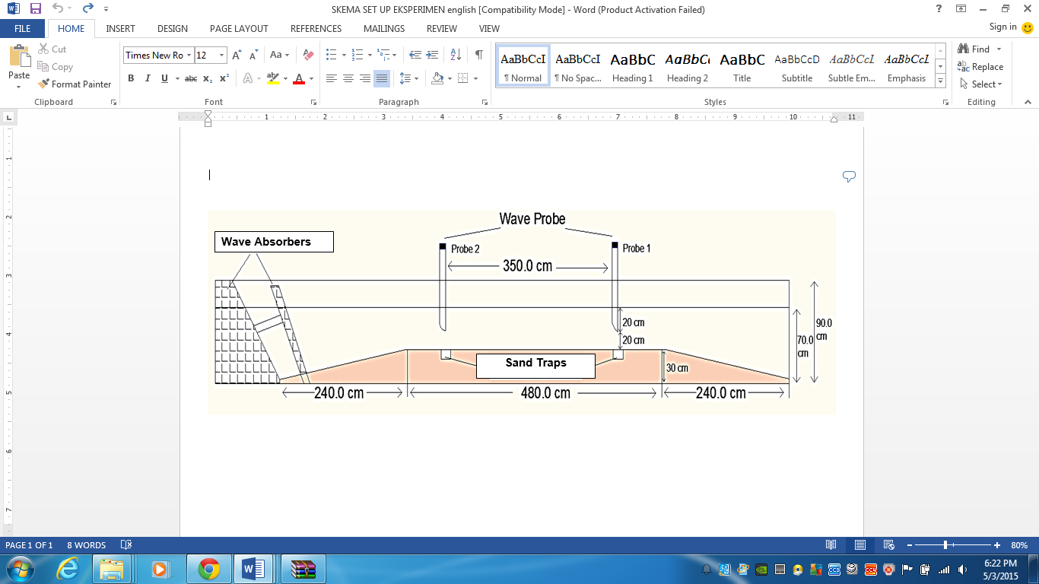

**Figure-1**. Experimental setup.

The time series of water surface elevation was measured by wave height sensor/wave probe placed in the vicinity of the sand trap. The free stream velocity was obtained by using the Fourier decomposition of the water surface elevation input **(t) given by Kaczmarek and Ostrowski [8] as follows,

$U\left(t\right)=\sum_{n}{η\left(t\right)\frac{nω}{sinh\left(k_{n}h\right)}sin\left(nωt+ϕ_{n}\right)+\frac{1}{2}U_{o}}$ (1)

in which *n * and *kn* are angular frequency and wave number related to each other by linear dispersion relationship, *n* is phase and *Uo* is the horizontal orbital velocity.

CALCULATION METHODS OF BOTTOM SHEAR STRESS

There are three calculation methods of bottom shear stress used to evaluate the bottom shear stress under irregular waves. Method 1 is the method proposed by Tanaka and Samad [9], Method 2 is the method proposed by Nielsen [10] and Method 3 is the new method based on the method proposed [1], as shown in Equation. (2) and Equation. (3).

 (2)

 (3)

Where, *am/ks* is roughness parameter, *ks* is bed roughness, *ks* = 2.5 *d50*, *Ua*(t) is the instantaneous of friction velocity as proposed by Suntoyo *et al*. [1] and Suntoyo and Tanaka [4].

**BED-LOAD SEDIMENT TRANSPORT MODEL**

The instantaneous bed-load sediment transport rate, *q*(*t*) is expressed as function of the Shields number *\**(*t*) given as follows [1,4,11],

 (4)

Here, **(*t*) is the instantaneous the dimensionless bed-load rate, *s* is sediment density, *g* is gravitational acceleration, *d50* is median diameter of grain size sand particle.

*A* is coefficient, *sign* is the sign of the function in the parenthesis, **\*(*t*) is the Shields parameter defined by (**(*t*)/(((*s/)-1*)*gd50*)) in which **(*t*) is the instantaneous bottom shear stress calculated by Method 1, Method 2 and Method 3, respectively. While **cr* is the critical Shields number calculated using the expression given in [1].

The net sediment transport rate, which is averaged over one-period along a wave cycles is expressed as follows



 (5)

Here, ** is the dimensionless net sediment transport rate, *F* is the function of Shields parameter and *qnet* is the net sediment transport rate in volume per unit time and width. In this study, the roughness high (*ks*) was defined *ks*=2.5 *d50*. Thus, a constant *A* used is 11. Moreover, the integration of Equation. (5) was assumed to be done only in the phase |*(*t*)|> *cr and during the phase |*(*t*)|< *cr the function of integration is assumed to be 0.

RESULTS AND DISCUSSIONS

**Performance of Bottom Shear Stress Calculation Methods**

The performance of bottom shear stress calculation methods were evaluated by the root-mean-square error (*RMSE*), as follow:

 (6)

where, *ocal.*: the bottom shear stress from calculation methods, *oexp*: the bottom shear stress from experimental results, *N*: the total number of data and *i*: index. If the calculation method is perfect, it can be indicated that the *RMSE* should be zero. It can be concluded that the smaller *RMSE* is better the performance of the calculation methods. The summary of calculation method performance of bottom shear stress is shown in Table-2.

**Table-2.** The summary of calculation method performance of bottom shear stress.

|  |  |  |  |
| --- | --- | --- | --- |
| **Exp.** | **The Root-Mean-Square Error (**RMSE**)** | | |
| **Method 1** | **Method 2** | **Method 3** |
| Tanaka et. al [7] | 8.69 | 3.07 | 1.95 |

The bottom shear stress experimental data from Tanaka *et al*. [7] for irregular wave used to examine the bottom shear stress calculation methods. Comparison among the experimental data and the calculation methods is given in Figure-2. As shown in Table-2 that the new method (Method 3) has highest performance than others methods with RMSE = 1.95. The new Method (*RMSE* = 1.95) is better than Method 1 (*RMSE* = 8.69) and Method 2 (*RMSE* = 3.07). The new method gave the smallest the *RMSE* value indicating that the new method has the best agreement with the bottom shear stress of experimental results provided by Tanaka *et al*. [7]. It can be concluded that the new method can be used to estimate the bottom shear stress under irregular waves and also the phase difference and acceleration coefficient (*ac*=0.485) that have been defined in Equation. (3) were sufficient for this calculation. Therefore, the new method can be used to calculate the bottom shear stress under irregular waves that can be further used to an input sediment transport model under irregular waves in practical application.

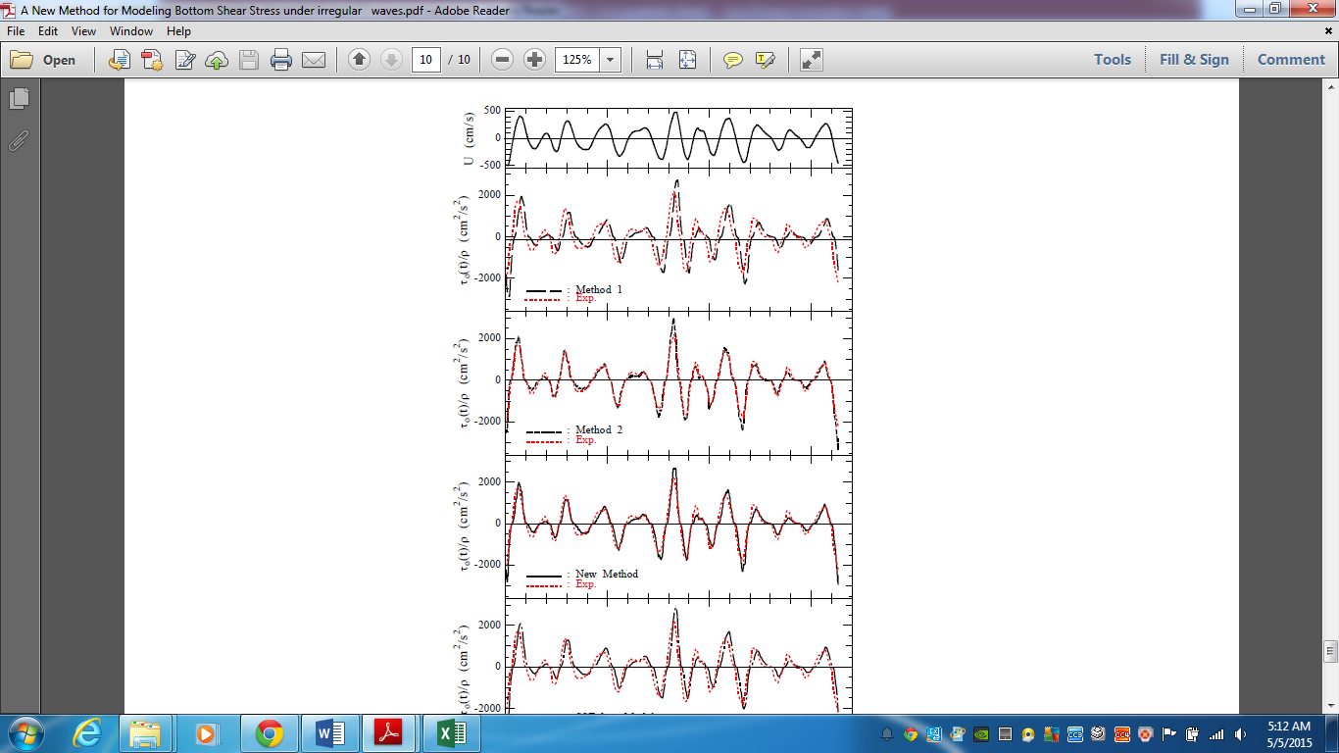

Figure-2. Comparison of the experimental data and the calculation methods of bottom shear stress.

**Bed-load Sediment Transport Modelling**

Furthermore, the calculation methods of bottom shear stress are applied to model the rate of bed-load sediment transport using Equation. 5. The methodology for predicting the wave orbital velocity, the bottom shear stress and the bed-load sediment transport time series for irregular waves was applied to a number of laboratory data sets. The exemplary results of the bed-load simulation are given in Figure-3. The upper part of this figure show the time series of water surface elevation (**(*t*)) followed by the time series of orbital velocity (*U*(*t*)), the time series of bottom shear stress (**(*t*))and the time series of bed-load sediment transport (*qb*(*t*)), respectively.



Figure-3. Time series of bottom shear stress and bed-load sediment transport.



Figure-4. Correlation between the net sediment transport rate of Method 3 and the experimental data.

The correlation between the net sediment transport rate predicted by Method 3 and the current laboratory experimental data sets as well as Dibajnia and Watanabe [12] data sets and Method 3 is shown in Figure-4. The solid line shows the value of the net sediment transport rate between Method 3 and the experimental data sets in the same value, while the correlation result between Method 3 and the experimental data is shown by • and o. It can be concluded that incorporating the acceleration effect in calculation of bottom shear stress has given a significant effect on the net sediment transport calculation. Therefore, the new calculation method of bottom shear stress Method 3 may be used to calculate the net sediment transport rate for irregular waves.



Figure-5. Comparison among the net sediment transport rate modelling based on calculation methods of bottom shear stress and the experimental data.

Comparison between experimental data and calculated net sediment transport rate for irregular waves was shown in Figure-5. Method 3 also has given the best agreement with laboratory experimental data sets of the net bed-load sediment transport for irregular waves, while Method 1 and Method 2 gave under estimate prediction for higher the significant orbital velocity, *U1/3*. Therefore, it can be concluded that the new method of bottom shear stress and the bed-load sediment transport rate for irregular waves could predict well the bed-load sediment transport rate for irregular waves that can be further used to an input for modelling morphological change in practical application, however, it should be examined with the field data.

CONCLUSIONS

The characteristics of the bottom shear stress and the bed-load sediment transport for irregular waves has been examined through both experimental data and the estimation model. Moreover, the new method of bottom shear stress gave the best agreement with the experimental data than others estimation methods. The new method also could predict well the bed-load sediment transport rate for irregular waves that can be further used to an input for modelling morphological change in practical application on near-shore.

**ACKNOWLEDGEMENTS**

The first author is grateful for the supported by Higher-Education, Ministry of Education and Culture RI, LPPM-ITS, Institut Teknologi Sepuluh Nopember (ITS) Surabaya, Indonesia. This research was partially supported by Grant of BOPTN-LPPM-ITS (No. 016458.17/ IT2.7/PN.01.00/2014) and by Grant of DIPA No. 023.04.1.673453/2015.

REFERENCES

1. Suntoyo, H. Tanaka, and A. Sana. 2008. Characteristics of turbulent boundary layers over a rough bed under saw-tooth waves and its application to sediment transport. Coastal Engineering*.* 55 (12): 1102-1112.
2. Jonsson, I.G. and N.A. Carlsen. 1976. Experimental and theoretical investigations in an oscillatory turbulent boundary layer. Journal of Hydraulic Research*,* 14(1): 45-60.
3. Tanaka, H., C.S. Chian, and N. Shuto. 1983. Experiments on an oscillatory flow accompanied with a unidirectional motion. Coastal Engineering in Japan*,* 26: 19-37.
4. Suntoyo and H. Tanaka. 2009. Effect of bed roughness on turbulent boundary layer and net sediment transport under asymmetric waves. Coastal Engineering.56(9): 960-969.
5. Suntoyo and H. Tanaka. 2009. Numerical modeling of boundary layer flows for a solitary wave. Journal of Hydro-environment Research. 3(3): 129-137.
6. Taufiqur Rachman and Suntoyo. 2012. Prediction of sediment transport due to irregular wave motion. Jurnal Ilmu dan Teknologi Kelautan Tropis, 3(2): 318-334.
7. Tanaka, H., T. Suzuki, Suntoyo and H. Yamaji. 2002. Time-variation of bottom shear stress under irregular waves over rough bed. Journal of Hydroscience and Hydraulic Engineering. 25(2): 217-225.
8. Kaczmarek, L.M. and Ostrowski, R. 1996. Asymmetric and Irregular Wave Effects on Bedload: Theory versus Laboratory and Field Experiments. Proceeding of The 26th International.Conference on Coastal Engineering, ASCE. 3467-3480.
9. Tanaka, H., and M.A. Samad. 2006. Prediction of instantaneous bottom shear stress for turbulent plane bed condition under irregular wave. Journal of Hydraulic Research.44(1): 94-106.
10. Nielsen P. 2002. Shear stress and sediment transport calculations for swash zone modeling, Coastal Engineering. 45: 53-60.
11. Suntoyo, Pratikto, W.A., Wijaya, M.M. and Tanaka, H. 2015. Characteristics of Sediment Concentration and Suspended Sediment Transport Due to Horizontal and Vertical Asymmetric Waves. Procedia Earth and Planetary Science. Vol. 14: 186-192.
12. Dibajnia, M. and A. Watanabe. 1998. Transport rate under irregular sheet flow conditions. *Coastal Engineering.* 35:167-183.