ANALYSIS OF THE PERFORMANCE OF MASSIVE MIMO SYSTEMS

Jesús David. Quintero, Martin D. Bravo and Diego Cuchimba

Department of Electronic Engineering, Surcolombiana University, Neiva, Colombia

E-Mail: jdavid[@usco.edu.co](mailto:diego.sendoya@usco.edu.co)

**ABSTRACT**

The fifth generation of mobile networks (5G) aims to meet the high demand for mobile data that will exist from the year 2021, product of the development of new technologies, applications and services. Its main requirements are to achieve high data transmission rates, massive user capacity, low power consumption, high communication reliability and low latency. Massive MIMO systems, those that use large antenna arrangements at the base station to transmit multiple users to the same time-frequency resource, have been proposed to address these demands. This work analyzes the performance of the MMSE, MRT and ZF linear precoding techniques for the massive MIMO downlink on a Rayleigh channel model, in terms of data rate, spectral and energy efficiency. It verifies that the linear processing is viable for the conditions of propagation that characterize these systems and that it improves the mentioned parameters.

**Keywords:** energy efficiency, spectral efficiency, MIMO massive, MMSE, MRT, linear precoding, ZF, 5G.

**INTRODUCTION**

Mobile data traffic is increasing by leaps and bounds, driven by the development of new technologies, devices, applications and services. By 2021, growth of at least 10 times the traffic measured during 2015, which was higher than 5 exabytes (EB) per month, was expected to grow by 65% ​​compared to that of 2014.

These 51 EB per month projected, about 90% will be associated with the use of smartphones. Today, GSM (Global System for Mobile Communications) and EDGE (Enhanced Data for Global Evolution) technologies dominate the worldwide subscriber market. At the end of the year 2015 reached a figure close to 7.4 billion subscriptions, of which 850 million correspond to users of LTE (Long-Term Evolution). However, considering the rapid rollout of the most advanced mobile telephone networks and the new needs of users, by 2021 an LTE domain with around 4.1 trillion subscriptions is expected, followed by WCDMA (Wide-band Code Division Multiple Access) and HSPA (High Speed ​​Packet Access). In a smaller amount, there will be users of other technologies and 5G (5th Generation mobile networks), which would be launched this year reaching a number of subscriptions in the order of 150 million. These statistics correspond to Ericsson's latest report (2015b).

The fifth generation of mobile telephony is the technological response to future challenges in terms of connectivity. In addition to offering improvements in mobile broadband services, such as high data rate, reliability and lower latency, its main objective is to support the complexity and high data demand resulting from integrating the Internet applications of objects (IoT, Internet of Things) to the network, without forgetting the commitment to maintain low energy consumption. The Internet of objects is the global infrastructure for the information society that facilitates the provision of advanced services through the interconnection of physical and virtual objects thanks to the interoperability of present and future Information and Communication Technology (ICT), 2012). As a result, Massive MIMO (MaMi, Massive MIMO) systems, those that use dozens to hundreds of antennas at communication terminals, have been proposed to meet these demands (Chockalingam and Rajan, 2014): by scaling MIMO systems Current to a higher order are obtained improvements in terms of spectral and energy efficiency, exploitation of more degrees of freedom, spatial-temporal multiplexing, decrease in latency and increase in the data rate of the system.

The concept of cellular communication system emerged in the search for a solution to the problem of spectral congestion and capacity of users of the first wireless communication systems, in which there was a single high-power transmitter over the entire coverage region. The idea was to divide the service area into small areas called cells, which are composed of a base station with a low power transmitter and operating with a portion of the available spectrum, increase the capacity of the system without incurring major technological changes (Rappaport, 2009). Consider the scenario of a cell whose base station has a coverage area (Km2) over which there is a density of users (users / Km2) that generates data traffic (bits / s / user). To satisfy this demand, the system must have a technology whose spectral efficiency (bits / s / Hz) allows it to exploit to the maximum the bandwidth (Hz) allocated for its operation. Faced with a possible increase in the demand for data of the system, three options can be considered to guarantee the service: increase, which means a greater use of the radio electric spectrum, which is a limited and expensive resource; Reduce by the deployment of more base stations over the coverage area; And / or increase through the standardization of more efficient technologies (Comes, *et* *al.*, 2010). If this situation is moved to the current proportions, where mobile data traffic will increase from 5 to 51 EB per month over the next six years, the need to increase the capacity of the system through new technologies to ensure Greater use of existing resources. MIMO technology focuses on increasing spectral efficiency by using multiple antennas in the transmitter and receiver. This type of transmission takes advantage of the diversity technique to guarantee the reliability of communication and the gain of spatial multiplexing to send multiple data streams, thus increasing system capacity (Goldsmith, 2005). With this principle the MIMO Massive systems are developed, which have base stations equipped with a large number of distributed antennas that serve many users in the same time-frequency resource (Ngo, 2012). The gain of diversity and multiplexing allows improving data transmission rate and energy efficiency, an important aspect at the environmental level: it is expected to improve the energy efficiency of mobile networks by an average of 2 kWh per gigabyte transmitted, in 2015, at an average of 0.25 kWh for 2021 (Ericsson, 2015b). In general, when large antenna arrangements are used in the base station, the channel vectors between the users and the base station are practically orthogonal favoring most propagation scenarios, so linear processing is feasible and not necessary to resort to more complex treatment techniques (Marzetta, 2010).

This work focuses on the study and analysis of the performance of the most accepted linear precoding techniques on the downlink of the Massive MIMO systems. Specifically, minimum-square error (MMSE), Zero Forcing and Maximum Ratio Transmission (MRT) are compared in terms of attainable rate of transmission, Spectral efficiency and energy efficiency.

**LITERATURE REVIEW**

**1. System model**

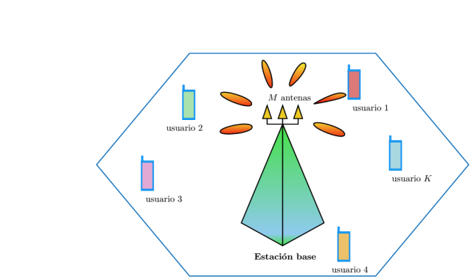

**Figure-1.** System model of Massive MIMO.

A MU-MIMO system consisting of a base station equipped with antennas and active users is considered, as shown in Figure-1. For convenience, the analysis is limited to the environment of a cell and to users with terminals of a single antenna. It is assumed that users share the same time-frequency resource and that favorable propagation conditions exist because the communication channel model includes the small-scale Rayleigh fading effects and ignores large-scale effects. The channel is considered to remain constant for a short coherence interval and is obtained at the base station during the training phase using the time division duplex (TDD) protocol, taking advantage of the reciprocity property of the channel. In this way, downlink transmission will have two phases: training and data transmission. During the training phase the base station obtains the channel status information (CSI) of each of the users from the training sequence received by the uplink. Subsequently, the base station uses this CSI value and a linear precoding scheme to process the data being transmitted. In order to evaluate the performance of the MMSE, ZF and MRT linear precoding techniques, it is assumed that the base station has perfect knowledge of the channel state and therefore does not negatively influence this process.

**2. DOWNWARD TRANSMISIÓN**

Let  be the vector representing the signal transmitted by the array of antennas in the base station. The signal received by the kth user can be noted as (Ngo, 2015):

 (1)

Where  represents the average power of transmission; is the channel vector between the kth user and the base station; is the additive noise in the kth user, which follows a Gaussian distribution with mean zero and unit variance. The set of signals received by the active users is represented by the vector:

 (2)

The base station uses the channel status information (CSI) obtained during the training phase to process the signals before transmitting them to the users. The process of linear precoding is explained below.

**3. PRE LINEAR ENCODING**

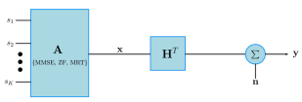

**Figure -2.** System block diagram.

The base station uses the channel status information (CSI) obtained during the training phase to process the signals before transmitting them to the users. The process of linear precoding is explained below.

Figure-2 illustrates the block diagram of the Massive MIMO downstream system using linear precoding. The signal transmitted from the antennas is treated as a linear combination of symbols intended for the users. Let the symbol for the k-th user satisfy, and the linear precoding matrix, which is a function of the channel matrix, the linearly precoded vector is (Ngo, *et al*., 2013b):

 (3)

Where and is the average transmission power of the base station. To satisfy this power constraint, the  precoding matrix must satisfy, or. Taking as reference the equation 2, the set of signals received by the K users is denoted:

 (4)



The linear precoding techniques under study are presented below.

**3.1 MMSE Precoding**

The precoding technique by means of a minimum error of the mean square error (MMSE) assumes that there will be interference between users, so its strategy is to minimize the average power of the error signal, i.e. the difference between the signal transmitted by the base station and the Signal estimated by the user, with a minimum quadratic error criterion. The precoding matrix that fulfills this characteristic is (Ngo, 2015):



In which represents the channel matrix, the K-size identity matrix, the average transmission power of the base station, K the number of users and the constant satisfying the power constraint, and which is equivalent to the expression:

 (6)



Note that the quotient is the value that maximizes the signal-to-noise-plus-interference ratio (SINR) in each receiving user, so the MMSE precoder is expected to perform optimally (Comes, *et al.*, 2010). However, it should be noted that it presents a high computational complexity, a factor that could become a disadvantage in relation to the speed of processing and the energy consumption of the devices.

**3.2 ZF Precoding**

The zero-forcing (ZF) precoding strategy completely eliminates the interference between users by projecting the signals to be transmitted over the orthogonal complement of the components causing the interference between users. Consider the k-th columns of the channel matrix and the precoding matrix respectively. The precoding process must be such that:



So that the components of users different from the one of interest are forced to zero. The precoding matrix that satisfies this property is the channel pseudo-inverse (Ngo, 2015):



Where represents the channel matrix and the constant that satisfies the  power constraint, which is equivalent to:

 (8)

This technique is characterized by good performance in propagation scenarios limited by interference signals. From equation 5 it can be pointed out that the ZF strategy approaches MMSE when the transmission power tends to infinity (). Indeed, considering that it does not take into account the existence of noise is preferred in situations where it is transmitted with high signal-to-noise ratio (SNR). In addition, its computational complexity is less compared to precoding based on MMSE.

**4. MRT PRECODING**

The maximum ratio transmission technique (MRT) is characterized by maximizing the signal to noise ratio (SNR) with which the base station transmits. The stronger the gain of a particular propagation channel between the base station and a given user, the greater the energy that is allocated to the signal transmitted by this path. This strategy performs well in noisy scenarios and its precoding matrix is the one with the least computational complexity (Ngo, 2015):



Where  represents the propagation channel matrix and  the constant that satisfies the power constraint, which in this case results:

 (10)

Based on equation 5 it can be said that the MRT precoding technique approaches MMSE when the average transmission power of the system tends to zero (). Its disadvantage is not to consider the possible existence of interference between the users of the system, which is why it presents a low performance on scenarios limited by this phenomenon.

**5. PARAMETERS CONSIDERED IN THE EVALUATION OF MASSIVE MIMO**

Massive MIMO systems have been proposed to meet the requirements of the fifth generation of mobile telephony (Larsson, et al., 2014). In order to study its potential, the performance of the system is evaluated from the quantification of attainable data rate, spectral efficiency and energy efficiency on different simulation scenarios. 5G requirements and capabilities can be summarized from Ericsson (2015a) and Nokia (2014):

Mass capacity: 10 to 100 times more connected devices. 10000 times more data traffic.

High data transmission rate: peak rates exceeding 10 Gbit / s in indoor scene

Low: less or iqual to 1 ms.

Ultra-high reliability and availability.

High energy efficiency of the network.

Low-cost devices and energy consumption.

**5.1 Attainable transmission rate**

The maximum data transmission rate is derived from the Shannon capacity theorem for channels affected by additive white Gaussian noise (AWGN), considering that all the parameters are random processes that follow a Gaussian distribution and that the channel is ergodic in nature. I.e. there is fading, but there are a large number of channel realizations that allow us to calculate the capacity as the mathematical expectation or expected value of instantaneous capacity. If it is taken into account that Massive MIMO allows multiple communications in parallel, the different channels established between the base station and the users can be considered independent and, consequently, the total capacity of the system will be given by the sum of the individual transmission rates. In correspondence with the above, the rate of data transmission in bits / s / Hz for the kth user can be noted:

 (11)

Where is the signal-to-noise plus interference ratio of the k-th user, which is derived immediately from equation 4? Be  and the k-th columns of their respective matrix and; and and the k-th elements of the vectors and, respectively. The signal received by the k-th user is:



Therefore, the signal-to-noise plus interference (SINR) ratio of the k-th user is given by:



Introducing equation 13 in 11 gives the general expression for the attainable rate of transmission of the kth user:



**5.2 Spectral efficiency**

The maximum data transmission rate is derived from the Shannon capacity theorem for channels affected by additive white Gaussian noise (AWGN), considering that all the parameters are random processes that follow a Gaussian distribution and that the channel is ergodic in nature. I.e. there is fading, but there are a large number of channel realizations that allow us to calculate the capacity as the mathematical expectation or expected value of instantaneous capacity. If it is taken into account that Massive MIMO allows multiple communications in parallel, the different channels established between the base station and the users can be considered independent and, consequently, the total capacity of the system will be given by the sum of the individual transmission rates. In correspondence with the above, the rate of data transmission in bits / s / Hz for the kth user can be noted:

 (15)

Where is the signal-to-noise plus interference ratio of the k-th user, which is derived immediately from equation 4? Be and the k-th columns of their respective matrices

**5.3 Power efficiency**

Energy efficiency is defined as the spectral efficiency divided by the power with which the transmission is performed. Thus, being the average transmission power of the base station in joules per second (J / s), the energy efficiency in bits / J / Hz can be noticed (Ngo, *et al*., 2013a):



Where and means Perfect CSI. In general, an increase in spectral efficiency is associated with the increase in the transmission power of the system, which in turn represents a decrease in energy efficiency. Therefore, there is a compromise between the spectral and energy efficiency to be evaluated.

**RESULTS AND DISCUSSIONS**

**Scenario I**

This scenario evaluates the system's attainable data rate in bits / s / Hz for each linear precoding technique as the number of antennas in the base station increases. For this purpose, consider that the number of active users in the cell is K = 10, while the number of antennas (M) is doubled by taking values of 20, 40 and 80. The results of the simulations are shown below for powers of transmission in the range of -20 to 30 dB. En este escenario se evalúa la tasa de transmisión de datos alcanzable del sistema en bits/s/Hz para cada técnica de precodificación lineal, a medida que aumenta el número de antenas en la estación base. Con este propósito, considérese que el número de usuarios activos en la célula es K=10, mientras que el número de antenas (M) se duplica tomando valores de 20, 40 y 80. Los resultados de las simulaciones se muestran a continuación para potencias de transmisión en el rango de -20 a 30 dB.

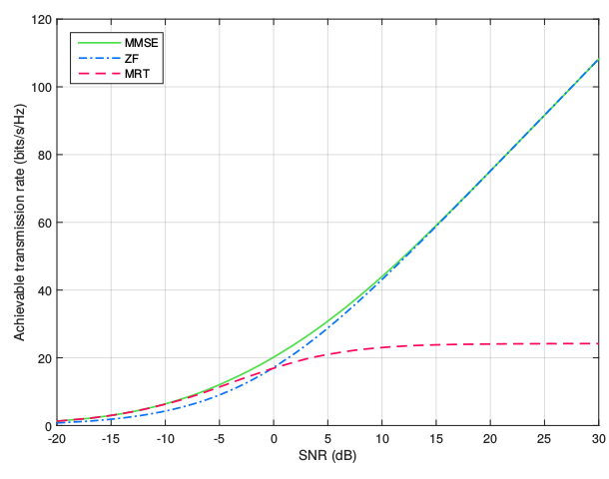

**Figure-3.** Attainable transmission rate with different SNR when M = 20 and K = 10.

According to the results of Figure-3, where M = 20 and K = 10, the MMSE-based precoder presents the best data transmission rate across the entire power range considered. On the other hand, the MRT precoder exhibits a good performance at low powers exceeding ZF in the range of -20 to 0 dB. The opposite occurs at higher power, where the ZF precoder broadly overcomes MRT and approaches MMSE as the transmit power of the base station increases.

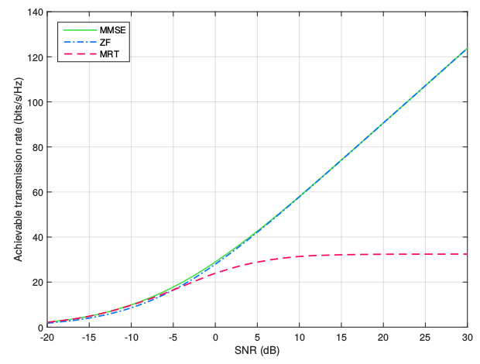

**Figure-4.** Transmission rate attainable with different SNR when M = 40 and K = 10.

In Figure-4 the number of antennas in the base station has been doubled to M = 40. Under these circumstances, the attainable data rate increases by 35% at a transmission power of 10 dB: about 14 bits / s / Hz for MMSE and ZF precoding techniques, and 8 bits / s / Hz for MRT. Comparison, the precoders have a behavior similar to that of the previous test being MMSE that dominates through the entire power range, while ZF performs well at high power and MRT at low power. However, it should be noted that the difference between the performances of the precoding techniques decreased whereby the curves tend to overlap.

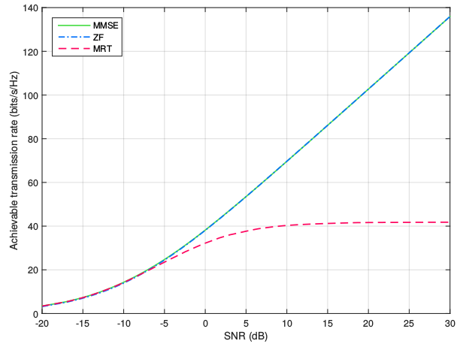

**Figure-5.** Transmission rate attainable with different SNR when M = 40 and K = 10.

In Figure-4 the number of antennas in the base station has been doubled to M = 40. Under these circumstances, the attainable data rate increases by 35% at a transmission power of 10 dB: about 14 bits / s / Hz for MMSE and ZF precoding techniques, and 8 bits / s / Hz for MRT. Comparison, the precoders have a behavior similar to that of the previous test being MMSE that dominates through the entire power range, while ZF performs well at high power and MRT at low power. However, it should be noted that the difference between the performances of the precoding techniques decreased whereby the curves tend to overlap.

Transmission rate attainable with different SNR when M = 80 and K = 10.

From Figure-5, where the number of antennas in the base station has been doubled to M = 80, an increase in the data rate of 20% at a power of 10 dB stands out: about 10 bits / s / Hz for MMSE and ZF precoding techniques, and 8 bits / s / Hz for MRT, with respect to the immediately preceding test. The performance of the ZF precoder improves to such an extent that its curve overlaps with that of MMSE practically over the entire power range. Accordingly, the ZF precoding technique is feasible to transmit at low power only when the number of antennas in the base station is much larger than that of active users.

From what is observed in Figures 3, 4 and 5, it is concluded that the rate of data transmission achievable by the system increases as the number of antennas in the base station becomes large. This is because propagation conditions are favorable provided, that is to say, there is a great diversity gain.

**Scenario II**

The system's attainable transmission rate is now evaluated for each linear precoding technique, as the number of active user’s increases. Consider that the base station has a fixed antenna number M = 80, while the number of users (K) takes values of 20, 40, 60 and 75.

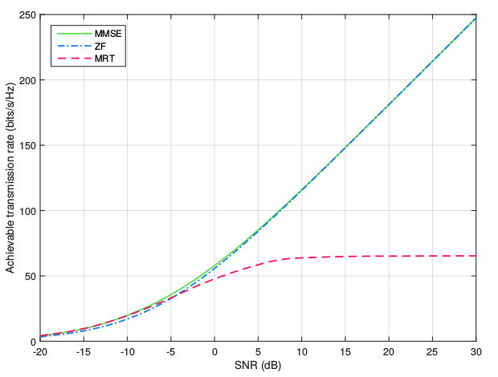

**Figure-6.** Attainable transmission rate with different SNR when M = 80 and K = 20.

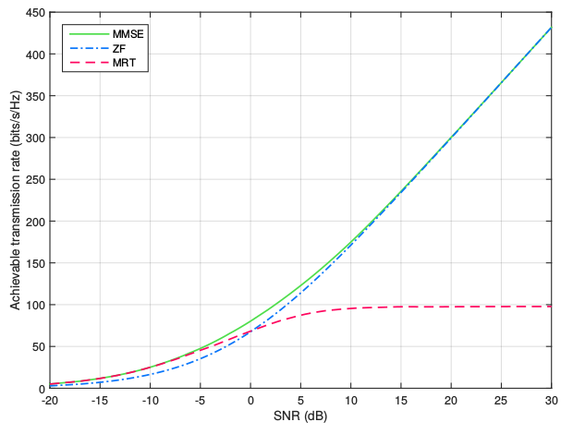

**Figure-7.** Attainable transmission rate with different SNR when M = 80 and K = 40.

According to the results of Figures 6 and 7, by doubling the number of active users from K = 20 to K = 40, the system data rate increased by 50% at a power of 10 dB: about 55 Bit / s / Hz for linear precoding techniques based on MMSE and ZF, and 30 bits / s / Hz for MRT based. This remarkable increase in the attainable data rate is due to the increase in multiplexing gain, which is equivalent to the minimum value between the number of active users and the number of antennas at the base station:  For MIMO systems with Multiple Users. Consequently, whenever, as is the usual case in Massive MIMO systems, the gain of multiplexing will depend on the number of active users at a given time.

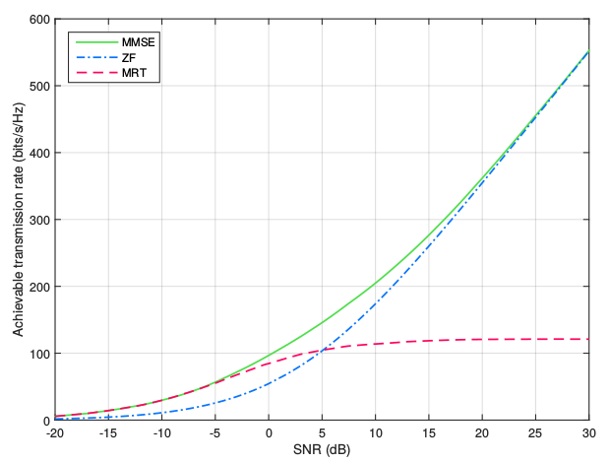

**Figure-8.** Attainable transmission rate with different SNR when M = 80 and K = 60.

In Figure-8 K = 60 users have been introduced to the system. In these circumstances, the increase in the data rate at a transmission power of 10 dB is 17% (30 bits / s / Hz) for the MMSE precoder, of 1.5% (2 bits / s / Hz) for ZF and 19% (18 bits / s / Hz) for the MRT case. In particular, the ZF precoding technique shows an insignificant performance improvement compared to the others, to the point that MRT exceeds it over a wider power range (from -20 to 5 dB) over previous tests.

Figure-9 corresponds to the results obtained when M = 80 and K = 75. The data transmission rate at a power of 10 dB increases by about 2% (4 bits / s / Hz) for the MMSE precoder and 14% (16 bits / s / Hz) for MRT. In contrast, the ZF technique presents a 56% (75 bits / s / Hz) decrease being greatly exceeded by MMSE across the entire power range, and by MRT in an even wider range: from -20 to 13 dB.

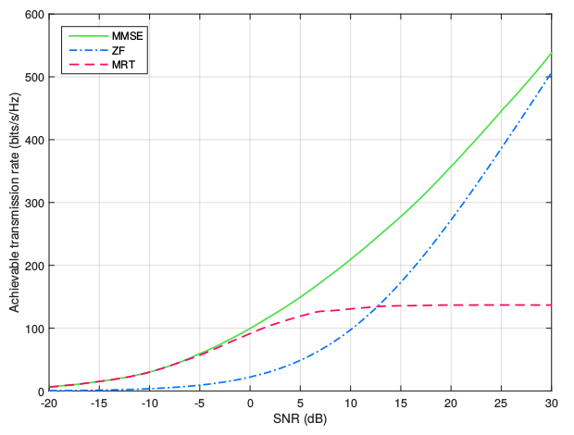

**Figure-9.** Transmission rate attainable with different SNR when M = 80 and K = 75.

The rate of data transmission achievable by the system increases significantly as more users are incorporated due to the increase in multiplexing gain. However, when the number of active users approaches the number of antennas in the base station, the propagation conditions are not ideal because the diversity gain is not large enough to guarantee multiple communication paths to each user. For this reason, the transmission rate stops growing at the same rate for MMSE and MRT precoding techniques and is even reduced in the case of ZF. The results also show that differences in the performance of the precoders become more noticeable as the number of users increases.

**Scenario III**

Once the feasible data rate of the system is studied, in this scenario we want to know how this capacity is distributed at the user level. For this purpose, consider the case studied in Figure-1, where M = 20 and K = 10. The rate of transmission per user when the base station transmits at a power of 6 dB is shown in Figure 10.

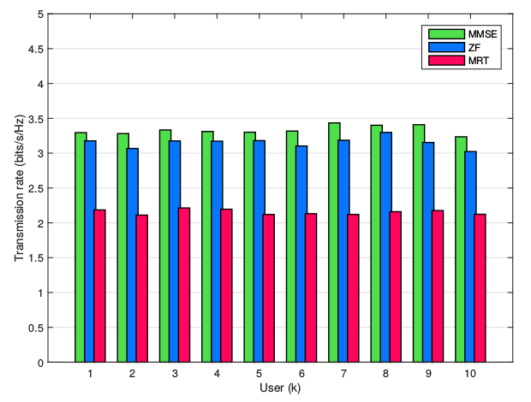

**Figure-10.** Transmission rate per user when M = 20, K = 10 and SNR = 6 dB.

According to the results obtained, each of the ten users has statistically the same capacity in terms of data transmission rate, according to the performance of the linear precoding technique used by the base station. Consequently, it can be argued that ideally the system capacity is evenly distributed among the active terminals, although in practice this depends on the good knowledge of the propagation conditions of each user.

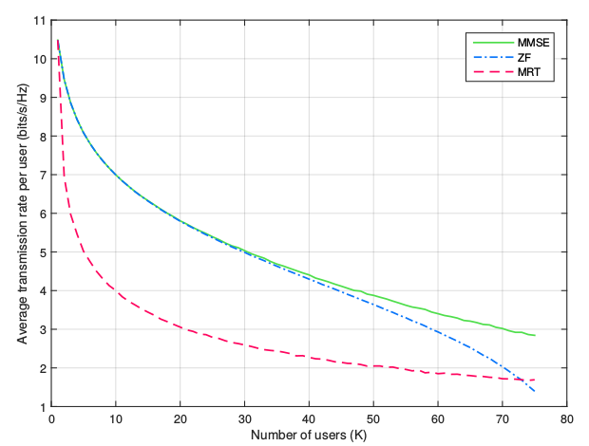

**Figure-11.** Average transmission rate per user vs. number of users when M = 80 and SNR = 10 dB.

To expand this exposure, the average transmission rate per user is examined in Figure 11 when the number of antennas in the base station is M = 80, transmitted with a power of SNR = 10 dB and the number of active users (K) Increases from 1 to 75. The results indicate that the average per-user transmission rate decreases as the number of users sharing system capacity increases. In particular, the performance of the ZF precoding technique is noticeably affected when, their use is justified where it can be guaranteed that.

**Scenario IV**

In this scenario, the spectral efficiency of the system is studied as the number of antennas and users increases. For the first case, consider the result of Figure-12, where the number of users is K = 10, the transmission power is SNR = 10 dB and the number of antennas (M) in the base station increases from 10 up to 10 500.

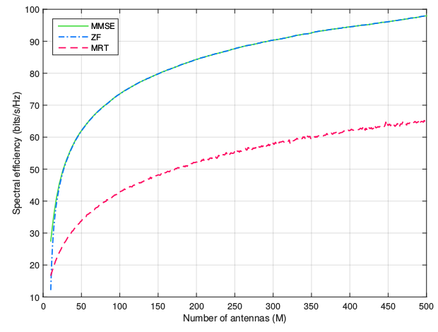

**Figure-12.** Spectral efficiency vs. number of antennas when K = 10 and SNR = 10 dB.

Here it is observed that the spectral efficiency of the system increases considerably when using an increasing number of antennas in the base station, for each one of the linear precoding techniques studied due to the gain of diversity. At the technology level, spectrum efficiency evolves from GSM with 0.05 bits / s / Hz (9.6 kbits / s over a band of 200 kHz) to 0.4 bits / s / Hz (2 Mbits / s over 5 MHz) with UMTS , At 3 bits / s / Hz (14 Mbits / s in 5 MHz) with HSPA and at 5 bits / s / Hz (100 Mbit / s over 20 MHz) with LTE, which if MIMO 4x4 can reach 16 bits / s / Hz (Comes, *et al*., 2010). In accordance with the above, Massive MIMO systems far outweigh the performance of cellular communication systems. For example, if 300 antennas are selected in the base station and MMSE precoded, the system offers a spectral efficiency of about 90 bits / s / Hz, which in a band of 20 MHz represents a speed of 1800 Mbits / s from which each of the 10 users uses 180 Mbits / s, thus fulfilling the requirement of 5G for urban scenarios.

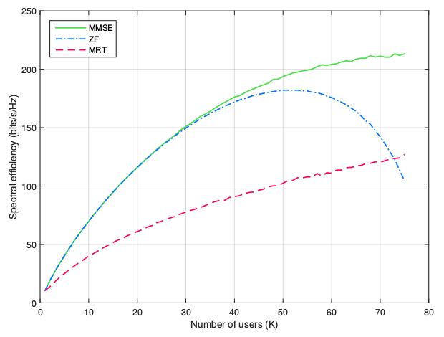

**Figure-13.** Spectral efficiency vs. number of users when M = 80 and SNR = 10 dB.

Figure-13 shows the case where a base station with M = 80 antennas transmit with a power of SNR = 10 dB to a number of users (K) that increases from 1 to 75. The spectral efficiency of the system increases to measure That K becomes large for the MMSE and MRT precoders, due to the multiplexing gain. In contrast, the spectral efficiency with ZF increases until the number of users is K = 53, and from this point begins to decrease product of that.

For the case where there are K = 30 active users and the linear precoding technique MMSE or ZF is used, the spectral efficiency is approximately 150 bits / s / Hz, representing 3000 Mbits / s in a bandwidth of 20 MHz : A speed of 100 Mbit / s for each user. This means that Massimo MIMO has the conditions to provide high capacity and high data rate, two of the main requirements for the next generation of mobile phone 5G.

Figure-13 shows the case where a base station with M = 80 antennas transmit with a power of SNR = 10 dB to a number of users (K) that increases from 1 to 75. The spectral efficiency of the system increases to measure That K becomes large for the MMSE and MRT precoders, due to the multiplexing gain. In contrast, the spectral efficiency with ZF increases until the number of users is K = 53, and from this point begins to decrease product of that.

For the case where there are K = 30 active users and the linear precoding technique MMSE or ZF is used, the spectral efficiency is approximately 150 bits / s / Hz, representing 3000 Mbits / s in a bandwidth of 20 MHz : A speed of 100 Mbit / s for each user. This means that Massimo MIMO has the conditions to provide high capacity and high data rate, two of the main requirements for the next generation of mobile phone 5G.

**Scenario V**

Finally, the compromise between spectral efficiency and energy efficiency is studied in this scenario. Consider the case where the base station transmits to K = 10 users using a number of antennas (M) that doubles by taking values of 20, 40 and 80. The result of the simulation corresponds to Figure 14, where at an efficiency 20 bits / s / Hz, the MMSE precoder has an energy efficiency of 20 bits / J / Hz when M = 20. By doubling the number of antennas at 40 and 80, the energy efficiency increases to 48 and 100 bits / J / Hz, respectively. In the case of the ZF precoder, the energy efficiency increases from 14 bits / J / Hz to 43 and 99 bits / J / Hz, as the number of antennas doubles. Regarding MRT, it starts with an energy efficiency of 10 bits / J / Hz and reaches 37 and 95 bits / J / Hz when doubling the number of antennas.

In correspondence with the above, when doubling the number of antennas in the base station the energy efficiency at least doubles by the same value of spectral efficiency, this because more antennas can better address the signal to each user avoiding excessive consumption Of energy. In general, the MRT precoder presents good performance at high energy efficiency and low spectral efficiency, while ZF offers better results at low energy efficiency and high spectral efficiency. The MMSE technique is the one that offers the best performance in the entire range of spectral efficiency.

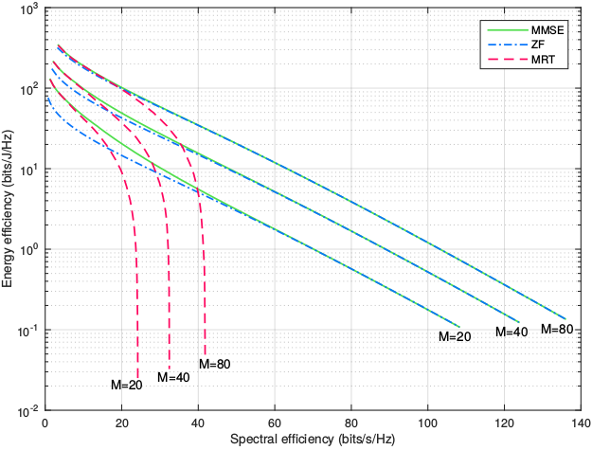

**Figure-14.** Energy efficiency vs. spectral efficiency when K = 10 and M = 20, 40 and 80.

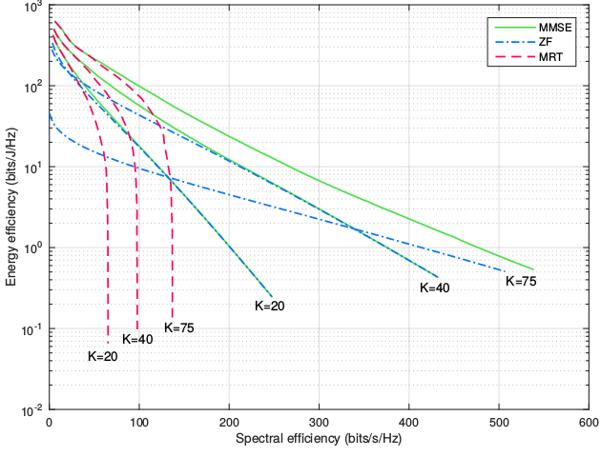

**Figure-15.** Energy efficiency vs. spectral efficiency when M = 80 and K = 20, 40 and 75.

Now consider the case where the base station has a fixed antenna number M = 80 and the number of active users (K) increases by 20, 40 and 75. The result of Figure 15 shows that for the linear MMSE and MRT, The energy efficiency increases as the number of active users in the system grows. Regarding ZF, the energy efficiency also increases but it begins to fall when the number of users approaches the number of antennas. Generally, MMSE offers the best energy efficiency in each case while MRT excels at high energy efficiency and low spectral efficiency. As a result, MIMO Massive also contributes to achieving the goals in terms of energy efficiency and low consumption of the fifth generation mobile telephony network.

**CONCLUSIONS**

Massive MIMO systems have the potential to significantly increase the spectral efficiency of the mobile network thanks to its efficient spatial multiplexing strategy. At the same time, they significantly improve energy efficiency by focusing the transmission energy according to the location of the users. These properties are possible when the base station uses a simple processing of the signals as the linear precoding techniques studied, which take advantage of the favorable conditions of propagation in an established coherence interval, allowing complying with the requirements of capacity level 5G, Rate of data transmission and energy efficiency.

The linear precoding technique based on MMSE achieves the best performance in terms of data rate, spectral and energy efficiency for most scenarios considered. However, in order to satisfy a high data demand whenever there is a large number of antennas in the base station in comparison with the number of active users, it is preferable to use the ZF precoder, which requires less computation and presents an optimum performance in these conditions. For scenarios with lower data traffic, it is feasible to use the MRT decoder because it can satisfy this demand using lower transmission power and computational complexity. These characteristics make it possible to adopt a precoding technique in particular according to the required capacity in a given location and to the power of the available transmission equipment.

From the compromise between spectral and energy efficiency, it is possible to configure an operating point according to the data traffic at a given time. For example, with a fixed number of antennas in the base station, during periods of low demand one can choose to establish a number of users, a precoding technique or a strategic transmission power, so that the MIMO system presents high efficiency Energy and low spectral efficiency but sufficient to meet the current data demand. In general, for a fixed number of users, by doubling the number of antennas in the base station and reducing transmission power by half, it is possible to achieve the same spectral efficiency as in normal conditions, i.e. the energy efficiency of the System doubles.

**ACKNOWLEDGEMENT**

To thank the reviewers of this work and the Vice-Ministry of research and social projection of the Surcolombian University.

**REFERENCES**

Bjornson E., Larsson E.G., Debbah M. 2016. Massive MIMO for Maximal Spectral Efficiency: How Many Users and Pilots Should Be Allocated? IEEE Transactions on Wireless Communications. 15.2: 1293-1308.

Cho Y.S., Kim J., Yang W.Y., Kang C.G. 2010. MIMO-OFDM Wireless Communications with MATLAB. Wiley (Ed). p. 439.

Chockalingam A., Rajan B.S. 2014. Large MIMO Systems. Cambridge University Press (Ed). p. 309.

Comes R.A., Álvarez F.B., Palacio F.C., Ferré R.F., Romero J.P., Roig O.S. 2010. LTE: Nuevas tendencias en Comunicaciones Móviles. Fundación Vodafone España (Ed). p. 431.

Cox C. 2012. An Introduction to LTE: LTE, LTE-Advanced, SAE and 4G Mobile Communications. Wiley (Ed). p. 324.

Ericsson. 2015. 5G Radio Access. Consultado el 10 de noviembre de 2015. <http://www.ericsson.com/res/docs/whitepapers/wp-5g.pdf>.

Ericsson. 2015. Ericsson Mobility Report. Consultado el 15 de diciembre de 2015. <http://www.ericsson.com/res/docs/2015/mobility-report/ericsson-mobility-report-nov-2015.pdf>.

Gao X., Edfors O., Rusek F., Tufvesson F. 2015. Massive MIMO Performance Evaluation Based on Measured Propagation Data. IEEE Transactions on Wireless Communications. 14.7: 3899-3911.

Gao X., Edfors O., Rusek F., Tufvesson F. 2011. Linear Pre-Coding Performance in Measured Very-Large MIMO Channels. Vehicular Technology Conference (VTC Fall). pp. 1-5.

Goldsmith A. 2005. Wireless Communications. Cambridge University Press (Ed), pp. 561.

ITU. 2012. Recommendation ITU-T Y.2060: Overview of the Internet of things. Consultado el 14 de octubre de 2015. [www.itu.int/rec/dologin_pub.asp?lang=e&id=T-REC-Y.2060-201206-I!!PDF-E&type=items](http://www.itu.int/rec/dologin_pub.asp?lang=e&id=T-REC-Y.2060-201206-I!!PDF-E&type=items).

Larsson E., Edfors O., Tufvesson F., Marzetta T. 2014. Massive MIMO for Next Generation Wireless systems. Communications Magazine, IEEE. 52.2: 186-195.

Li Y., Xin Y., Dong M., Xu G., Zhang J.C., Kim Y., Lee J. 2013. Implementation of full-dimensional MIMO (FD-MIMO) in LTE. Signals, Systems and Computers, Asilomar Conference. pp. 998-1003.

Marzetta T.L. 2010. Noncooperative Cellular Wireless with Unlimited Numbers of Base Station Antennas. IEEE Transactions on Wireless Communications. 9.11: 3590-3600.

Molisch A.F. 2012. Wireless Communications. Wiley (Ed). p. 827.

Ngo H.Q. 2015. Massive MIMO: Fundamentals and System Designs. Tesis doctoral en Linköping University, The Institute of Technology. p. 45.

Ngo H.Q. 2012. Performance Bounds for Very Large Multiuser MIMO Systems. Tesis en Linköping University, The Institute of Technology. p. 23.

Ngo H.Q., Larsson E.G., Marzetta T.L. 2013. Energy and Spectral Efficiency of Very Large Multiuser MIMO Systems. IEEE Transactions on Communications. 61.4: 1436-1449.

Ngo H.Q., Larsson E.G., Marzetta T.L. 2013. Massive MU-MIMO Downlink TDD Systems with Linear Precoding and Downlink Pilots. 51st Conference on Communication, Control, and Computing (Allerton). pp. 293-298.

Nokia. 2014. 5G Uses cases and requirements. Consultado el 10 de noviembre de 2015. < http://networks.nokia.com/sites/default/files/document/5g_requirements_white_paper.pdf>.

Panzner B., Zirwas W., Dierks S., Lauridsen M., Mogensen P., Pajukoski K., Miao D. 2014. Deployment and Implementation Strategies for Massive MIMO in 5G. Globecom Workshops. pp. 346-351.

Rappaport T.S. 2009. Wireless Communications: Principles and Practice. Prentice Hall (Ed). p. 641.

Rusek F., Persson D., Lau B. K., Larsson E. G., Marzetta T. L., Edfors O., Tufvesson F. 2013. Scaling Up MIMO: Opportunities and Challenges with Very Large Arrays. IEEE Signal Processing Magazine. 30.1: 40-60.

Shen J. C., Zhang J., Letaief K. B. 2015. Downlink User Capacity of Massive MIMO under Pilot Contamination. IEEE Transactions on Wireless Communications. 14.6: 3183-3193.

Tranter W.H., Shanmugan K.S., Rappaport T.S., Kosbar K.L. 2004. Principles of Communication Systems Simulation with Wireless Applications. Prentice Hall (Ed). p. 778.

Vu M., Paulraj A. 2007. MIMO Wireless Linear Precoding. IEEE Signal Processing Magazine. 24(5): 86-105.